**BELLABEAT MARKETING STRATEGY**

Bellabeat is a high tech company that manufactures health-focused smart products. Bellabeat is all about empowering women by providing the knowledge about their health and habits. Bellabeat products includes;

Bellabeat app: This app provides users with health data related to their activity, sleep, stress, menstrual cycle and mindfulness habits. This app connects to other smart wellness products owned by Bellabeat

Leaf: This is a wellnedd tracher that can be worn as a bracelet, necklace or clip. Helps to track activity, sleep and stress

Time: This wellness watch allows users track activity, sleep and stress.

Spring: A water bottle that tracks daily water intake allowing users track hydration levels

The aim of this analysis is to discover new growth opportunities for the company by analyzing how people use smart devices. The objective is to understand how users interact with Bellabeat’s products—specifically the Leaf, Time, and Spring devices—by leveraging fitness tracker data from Fitbit users. These insights will inform marketing strategies to enhance product positioning and drive growth.

**DATA**

For this project, the dataset ‘Fitbit fitness dataset’ publicly on kaggle was used. The specific csv files used were daily activities, heart rate, hourly calories, hourly steps, minute sleep, sleep day, weightlog info.

**CLEANING AND MANIPULATION OF DATA**

**Data Cleaning**:

* **Removed Duplicates**: Ensured there were no duplicate entries in the Fitbit dataset.
* **Handled Missing Values**: Imputed missing values where appropriate by using the filling method
* **Standardized Formats**: Converted all time stamps and measurement units to a consistent format.

**Feature engineering**: Created a new column called Day of the week and hour

**SUMMARY OF ANALYSIS**

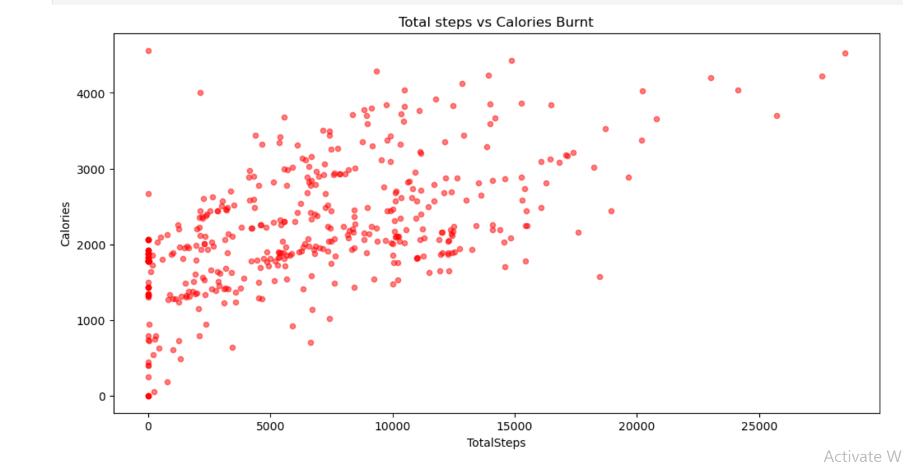

The figure above shows the positive correlation between the number of steps taken and the calories burnt

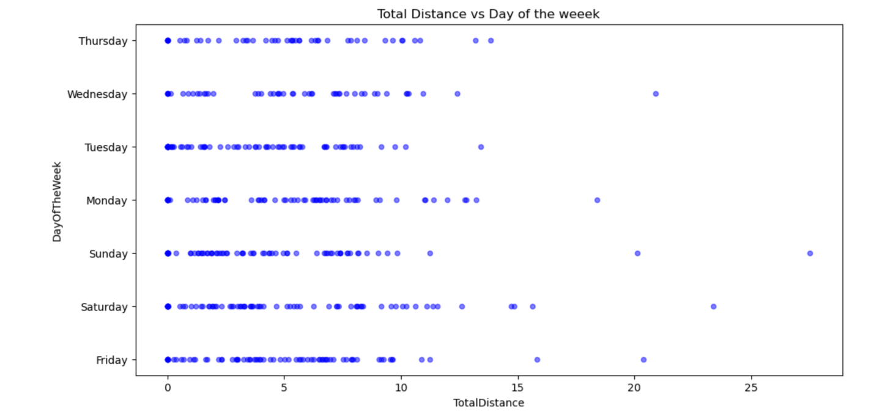The image above shows the total distance in respect to the day of the week with Saturday having the highest total distance taken in the week.

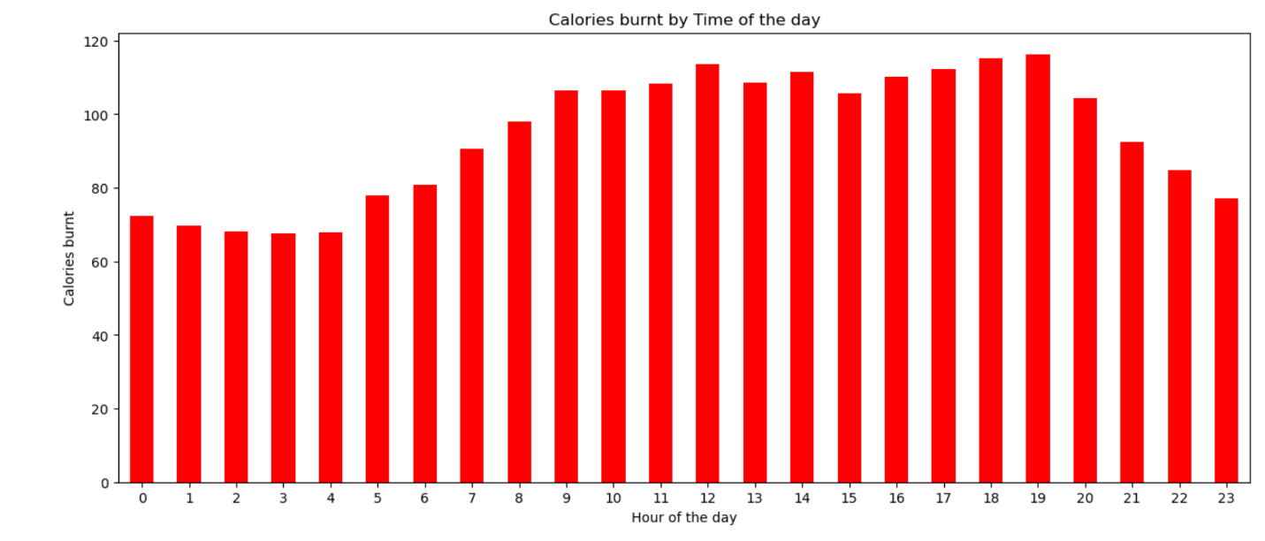To observe the best time the most calories was burnt, the graph above was plotted with 6pm and 7pm taking the lead

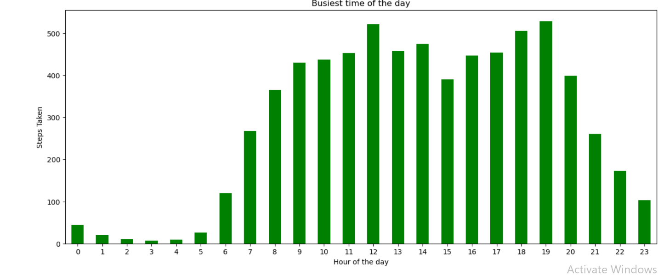

To emphasize on the calories burnt, we observed the busiest time of the day in respect to the number of steps taken per day. The graph above shows 7pm to be the busiest time with the highest number of steps taken, with 12pm coming next and 6pm

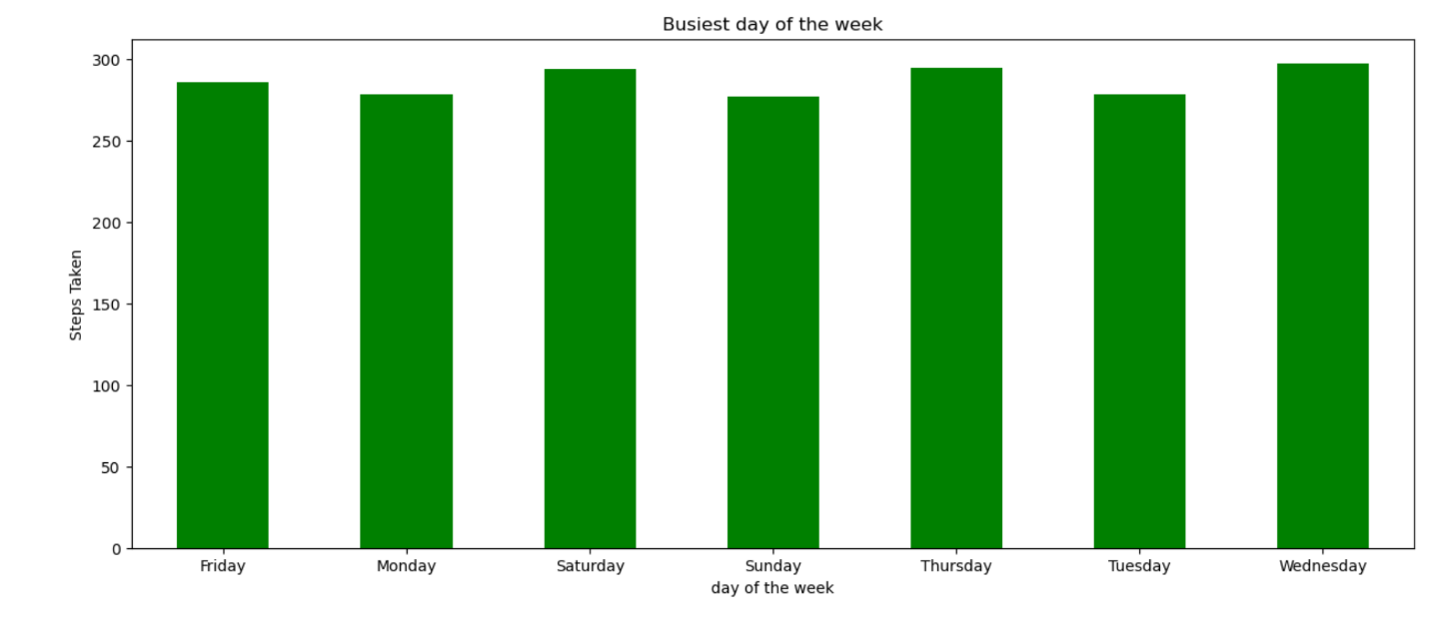The busiest day of the week seems to be Saturday and Sunday having the lowest number of steps taken.

To further understand the activity of users, analyzing the heart rate was done. From the Image below, the highest heart rate was at 4pm, 7pm and then 3pm. My assumption would be that this is as a result of number of steps taken at this time or the activities done within this time period.

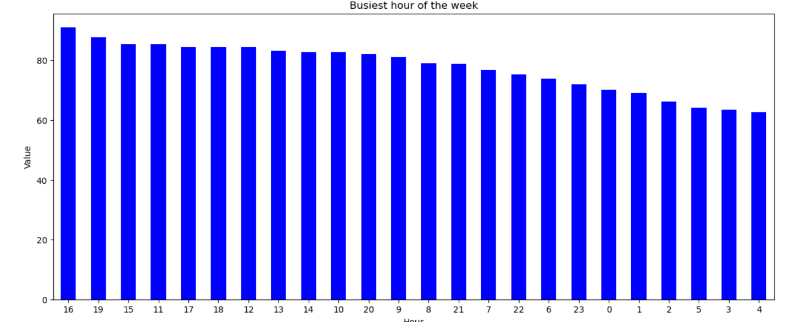

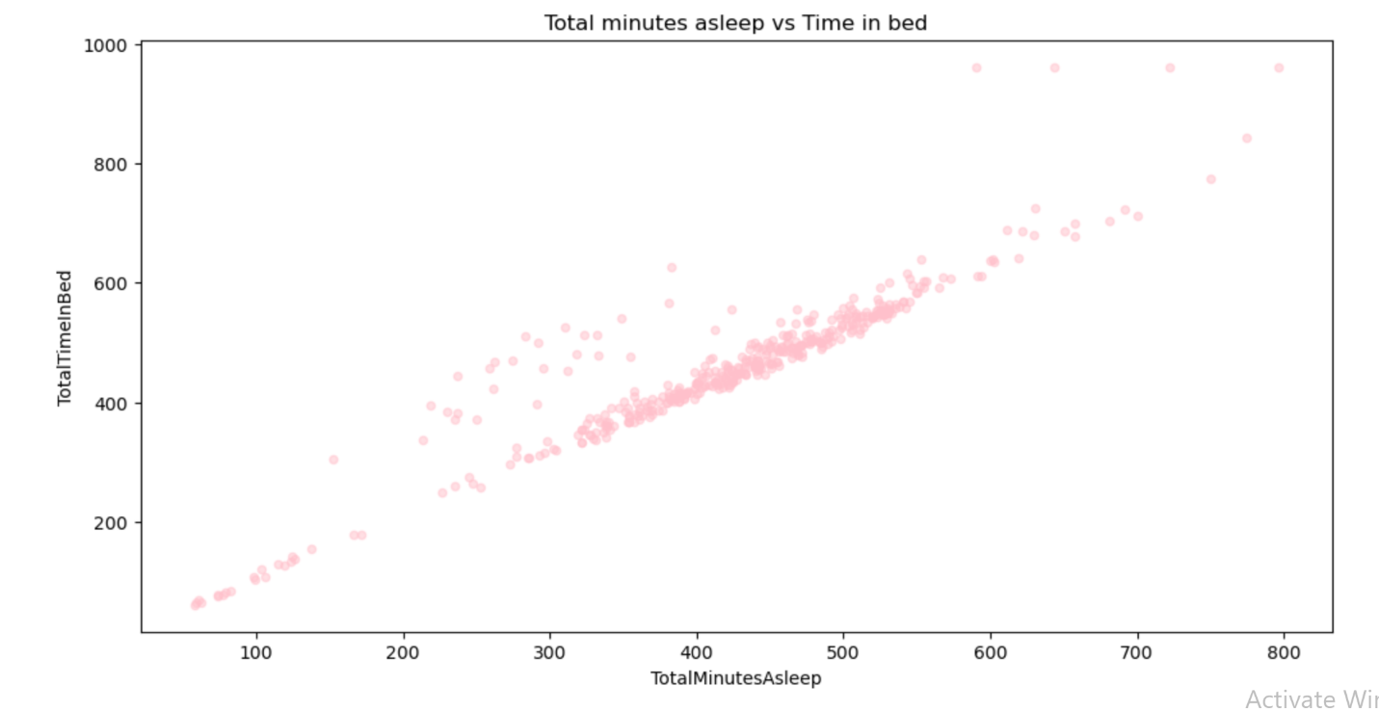Understanding users sleep was also one of the business objective. First we observed the correlation between the total minutes in bed and the total minutes asleep and found a strong positive correlation to the two. Delving a bit deeper into this data, we looked at the total minutes asleep by the day of the week finding Sunday taking the lead which is understandable as it had the lowest number of steps taken in the analysis of steps above. The image below provides a clearer picture,

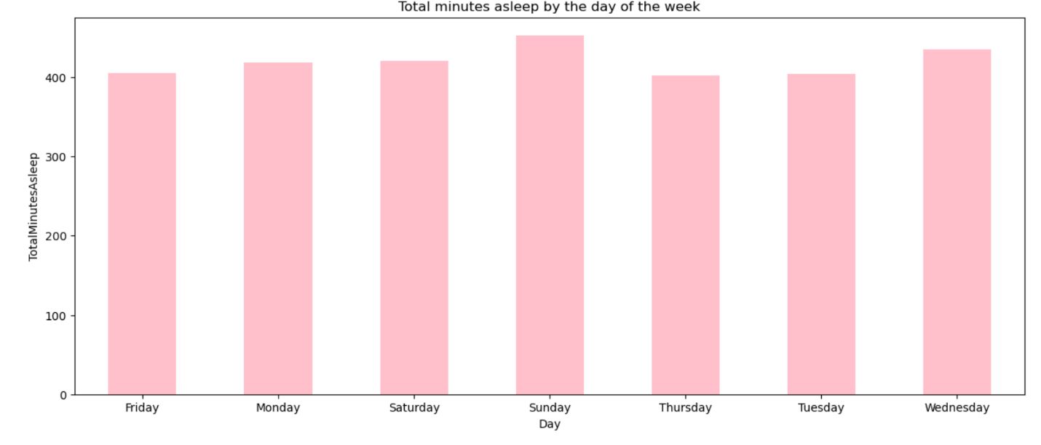

With further analysis, it was discovered that the total minutes in bed doesn’t exactly equate to the total minutes asleep. Could it be as a result of difficulty falling asleep or spending more time scrolling through social media before falling asleep?

The image below shows the duration of sleep of users and you would observe that some users had less duration of sleep than the total minutes spent in bed.

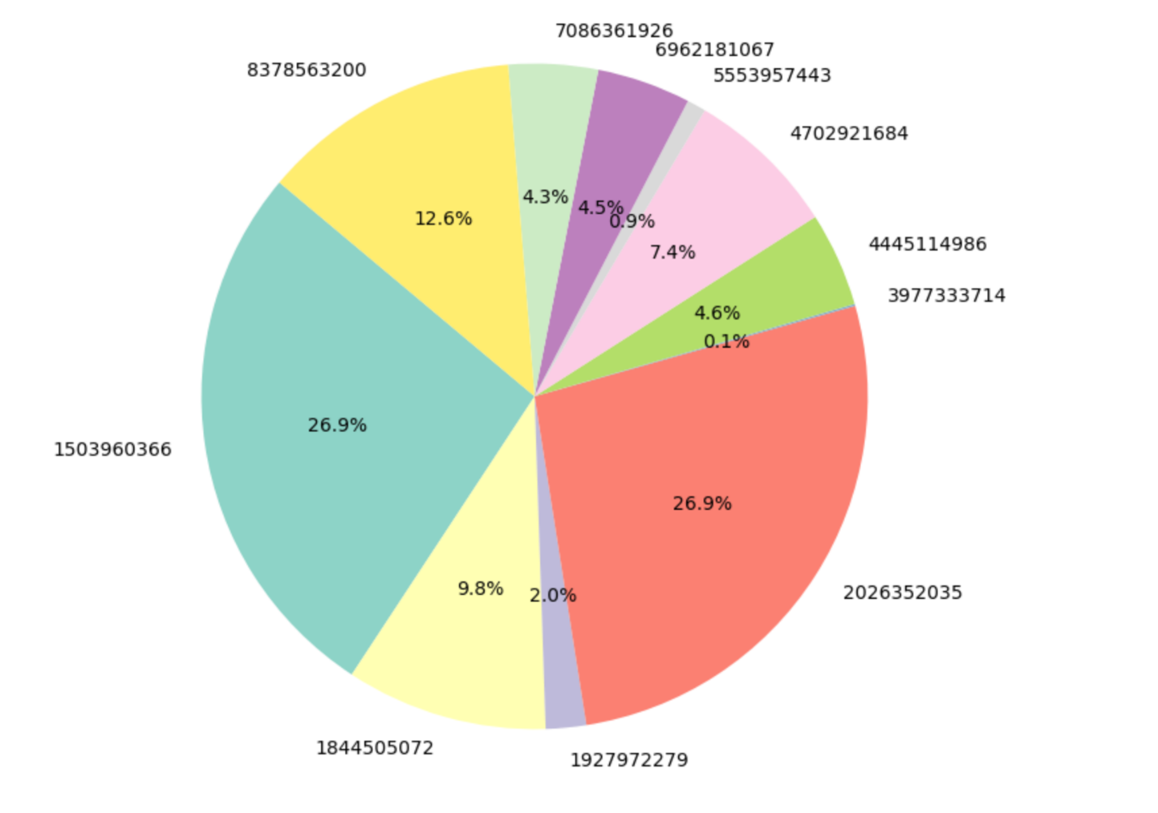

**RECCOMENDATIONS**

How can Bellabeat use this information to find growth opportunities?

1. Users enjoys tracking their steps and seeing the calories lost. Bellabeat could leverage on this information by ensuring their products have these features with possible reminders for users to hit their set goals for the day
2. Leverage on how exercising can be of great benefits for good sleep**.** Encouraging users to exercise in order to get good sleep
3. In order to track users sleep, not a lot of data was found which could be as a result of users not fancying wearing smartwatch to sleep. This puts bellabeat at an advantage by promoting the leaf product that could be worn as either a bracelet or necklace which allows users to easily wear when going to bed and track their sleep habits.